International School
Software Requirements Specification (SRS) Document
Course: System Integration Practices
Project Title: Integrated HR & Payroll Dashboard System for Company X
Case Study 2, 3: System Requirement Analysis & API Design
Version: 1.0
Date: Jan 21, 2026
Group: 5
Semester: [2 – 2025-2026]
Instructor: MSc. Nguyen Dang Quang Huy
Team Members:
Name | Student ID
Manh, Nguyen Van Duy | 29211100024
Loi, Tran Van | 29211159367
Loc, Tran Viet | 29211352994
Tin, Huynh Tran | 29211358847
Viet, Dang Dai | 29211155820

Approved by
MSc Huy, Nguyen Dang Quang

Da Nang 05/2026
Project Acronym | HRD
Project Title | Company X – Integrated HR & Payroll Management Dashboard
Start Date | 18 Jan 2026 | End Date | 9 May 2026
Lead Institution | International School, Duy Tan University
Role | Name | Email |  | Phone
Project Mentor | Nguyen Dang Quang Huy | Huyndq@dtu.edu.vn
Team Members | Nguyen Van Duy Manh | duymanhdev@gmail.com |  | 0779534325
 | Tran Van Loi | tvl19012005@gmail.com |  | 0898238541
 | Tran Viet Loc | tranvietloc288@gmail.com |  | 0365957050
 | Huynh Tran Tin | trantin202ad@gmail.com |  | 0899565751
 | Dang Dai Viet | vdang9721@gmail.com |  | 0384165721

DOCUMENT INFOMATION
Document Title | Software Requirements Specification (SRS)
Reporting Period | 09– May - 2026
Author(s) | Nguyen Van Duy Manh  Tran Viet Loc  Huynh Tran Tin
Role | Developer
Date | 01/02/2026 | File name | 4. Softtware Requirement Specification_IEEE 830-1998.docx

DOCUMENT APPROVALS
Document Approvals: The following signatures are required for approval of this document.
Mentor | Huy, Nguyen Dang Quang | Signature:
 |  | Date:
Team member(s) | Nguyen Van Duy Manh | Signature:
 |  | Date:
 | Tran Viet Loc | Signature:
 |  | Date:
 | Huynh Tran Tin | Signature:
 |  | Date:
 | Tran Van Loi | Signature:
 |  | Date:
 | Dang Dai Viet | Signature:
 |  | Date:

TABLE OF CONTENTS
I. Introduction 8
1.1. Purpose of the Document 8
1.2. Scope of the Document 8
1.3. Definitions, Acronyms, and Abbreviations 8
1.4. References 9
1.5. Overview 9
2. Overall Description 10
2.1. Purpose of the System 10
2.2. Scope of the System 10
3. Overall Description 10
3.1. Product Perspective 10
3.2. System Context Diagram 11
3.2. Product Functions 11
3.3. User Characteristics 11
3.4. Constraints 12
3.5. Assumptions and Dependencies 12
4. Specific Requirements 13
4.1. Functional Requirements 13
4.2. Non-functional Requirements 14
4.3. External Interface Requirements 15
5. System Models 16
5.1. Business Function Diagram (BFD) 16
5.2. List of Use Case 16
5.3. Use Case Diagram Overview 17
5.4. Use Case Specification 18
5.4.1. UC.01: System Login 18
5.4.2. UC.02: User Account Management 19
5.4.3. UC.03: User Authorization 21
5.4.4. UC.04: Department Management 23
5.4.5. UC.05: HR Management 25
5.4.6. UC.06: HR Statistics 27
5.4.7. UC.07: Salary Statistics 29
5.4.8. UC.08: Attendance Tracking 31
5.4.9. UC.09: Salary Update 32
5.4.10. UC.10: Create Excess Leave Alert 34
5.4.11. UC.11: Salary Fluctuation Notification 36
5.5. Activity Diagram 39
5.5.1. UC.01: System Login 39
5.5.2. UC.02: User Account Management 40
5.5.3. UC.03: User Authorization 41
5.5.4. UC.04: Department Management 42
5.5.5. UC.05: HR Management 43
5.5.6. UC.06: HR Statistics 44
5.5.7. UC.07: Payroll Statistics 45
5.5.8. UC.08: Timekeeping 46
5.5.9. UC.09: Update Salary 47
5.5.10. UC.10: Excess Leave 48
5.5.11. UC.11: Salary Change Notification 49
5.6. Sequence Diagram 50
5.6.1. UC.01: System Login 50
5.6.2. UC.02: User Account Management 51
5.6.3. UC.03: User Authorization 52
5.6.4. UC.04: Department Management 53
5.6.5. UC.05: HR Management 54
5.6.6. UC.06: HR Statistics 55
5.6.7. UC.07: Salary Statistics 56
5.6.8. UC.08: Timekeeping 57
5.6.9. UC.09: Update Salary 58
5.6.10. UC.10: Excess Leave 59
5.6.11. UC.11: Salary Change Notification 60
5.7. Class Diagram 61
6. Other Requirements 61
6.1 Business Rules 61
6.2. System Constraints 62
7. Appendix 63
7.1. Glossary 63
7.2. Appendix B – Requirement Traceability Matrix 64

I. Introduction

1.1. Purpose of the Document
- This Software Requirements Specification (SRS) document is developed to describe in detail all the requirements of the Integrated HR & Payroll Dashboard System for Company X.
- It serves as a foundation for system development, testing, and maintenance throughout the software lifecycle.
- The intended audience of this document includes:
- Customer (Company X): to understand how the system meets human resource and payroll management needs.
- Supervisor/Lecturer: to monitor progress and evaluate learning outcomes.
- Development Team (students): to use as a reference for design, implementation, and testing.
- Testing Team: to build and execute test cases based on the requirements.

1.2. Scope of the Document
- This document includes:
- Detailed descriptions of functional requirements (FR) and non-functional requirements (NFR).
- System models including Use Case, Activity, Sequence, Class, and State Diagrams.
- Business rules and technical constraints.
- This document does not include:
- Technical implementation details, source code, or deployment instructions for the actual system.

1.3. Definitions, Acronyms, and Abbreviations
Abbreviation | Meaning
HR | Human Resource
FR | Functional Requirement
NFR | Non-functional Requirement
DB | Database
API | Application Programming Interface
JWT | JSON Web Token
RBAC | Role-Based Access Control
CRUD | Create, Read, Update, Delete
KPI | Key Performance Indicator

1.4. References
- IEEE Computer Society, IEEE Recommended Practice for Software Requirements Specifications (IEEE Std 830-1998), 1998.
- CEO Memo – Company X (2025).
- Business Requirement Document (BRD) – Group 5 (2025).
- System Integration Practices Lecture Notes – MSc. Nguyen Dang Quang Huy (2025).
- Designing Data-Intensive Applications – Martin Kleppmann, O’Reilly (2017).

1.5. Overview
- Chapter 2: Overall system description.
- Chapter 3: General requirements and user description.
- Chapter 4: Specific requirements (Functional Requirements & Non-Functional Requirements).
- Chapter 5: System modeling using UML diagrams.
- Chapter 6: Business rules and constraints.
- Chapter 7: User interface prototypes

2. Overall Description

2.1. Purpose of the System
- The purpose of the Integrated HR & Payroll Dashboard System is to support Company X in integrating human resource data (HUMAN_2025 – SQL Server) and payroll data (PAYROLL – MySQL) into a unified platform.
- The system helps to:
- Manage employees, departments, salaries, and attendance.
- Automatically synchronize data between the two databases.
- Provide reports and intelligent alerts for managers.

2.2. Scope of the System
- The HR & Payroll Dashboard System will provide the following main functionalities:
- Employee profile management.
- Attendance tracking and automated payroll calculation.
- Notifications for birthdays, work anniversaries, and upcoming contract expirations.
- Visual reporting (tables and charts).
- Support for multiple user roles: Admin, HR Manager, Payroll Manager, and Employee.
- Out of scope:
- Integration with ERP systems or external services.
- Automatic notifications via SMS or email.

3. Overall Description

3.1. Product Perspective
- The system is a standalone web application that connects simultaneously to two databases:
- HUMAN_2025 (SQL Server): stores human resource data.
- PAYROLL (MySQL): stores payroll and attendance data.
- The system acts as a middleware integration layer, using RESTful APIs to transfer data between the backend and frontend.

3.2. System Context Diagram
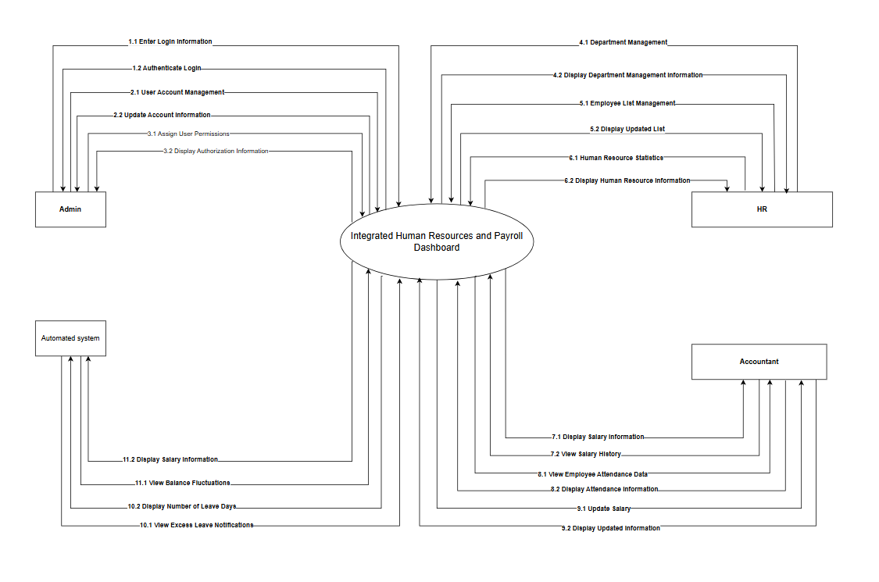

3.2. Product Functions
- The main system functions include:
- User authentication and authorization.
- Department and position management.
- User account management.
- Department management.
- Human resource (employee) management.
- HR statistics and reporting.
- Payroll statistics and reporting.
- Attendance tracking.
- Salary updates and adjustments.
- Excess leave management.
- Salary fluctuation tracking.

3.3. User Characteristics
User Type | Description | Skills
Admin | Manage users, assign permissions, and configure the system. | Basic IT skills
HR Manager | Manage profiles, contracts, and employees. | HR expertise
Payroll Manager | Manage payroll, allowances, and deductions. | Financial expertise
Employee | View profile, attendance history, and salary. | General user

3.4. Constraints
- The application runs on the web and supports Chrome and Edge browsers.
- Must comply with human resource data security policies.
- Middleware architecture: Acts as an intermediate layer connecting two distributed databases simultaneously: SQL Server (HUMAN_2025) and MySQL (PAYROLL).
- Preservation of original databases: Must not modify the schema of the HUMAN_2025 and PAYROLL databases. Extended features (such as alerts) must be handled at the Dashboard application layer.
- Secure communication: Data transmission between servers and browsers must be encrypted using SSL/TLS, with JWT used for authentication.
- Password security: User passwords must be encrypted (hashed) and must never be stored in plain text.
- Response time: Data retrieval and reporting operations must ensure responses within 2 seconds.
- Privacy compliance: Payroll data is sensitive and must be strictly access-controlled; employees are only allowed to view their own data.
- Server environment: The system must support flexible deployment on both Windows Server (IIS) and Linux Server (Tomcat).

3.5. Assumptions and Dependencies
- Assumptions
- Each employee in the company is provided with or owns a valid, unique email account to receive login credentials, notifications, and electronic payslips (E-Payslip).
- System users (Admin, HR, Accountant, Employee) possess basic computer skills and have access to devices (PC, Laptop, Smartphone) with modern web browsers installed.
- Company X’s HR policies (e.g., maximum of 12 leave days per year) and payroll structure will not undergo significant changes that would disrupt the core system logic during the project development period.
- Dependencies
- The system fully depends on the availability and structural stability of two independent databases: HUMAN_2025 (SQL Server) and PAYROLL (MySQL).
- A stable network connection (Internet/Intranet) is required to maintain communication between the client, middleware server, and database servers.
- The “Salary fluctuation notification” feature depends on the stable operation of an SMTP server or a third-party messaging service.
- Raw attendance data (check-in/check-out times) is assumed to be accurately preloaded into the PAYROLL database by a hardware system (time attendance machine) before accountants interact with the Dashboard.

4. Specific Requirements

4.1. Functional Requirements
Code | Functional Requirement Description | Priority
FR.SYS.01 | The system allows users to authenticate their identity using a Username and Password to access the system based on their assigned permissions; supports the forgot password function. | High
FR.ADM.01 | Allows the Admin to manage user accounts, including: adding new accounts, assigning roles (HR, Accountant), and deactivating (locking) accounts. | High
FR.HR.01 | Allows HR to manage the personnel list: add new employee profiles, update personal information, and change employment status. | High
FR.HR.02 | The system provides reports and statistical charts on HR metrics (headcount, turnover/fluctuation, distribution by department) and allows exporting to Excel/PDF files. | Medium
FR.KT.01 | The system aggregates and displays payroll statistical reports (actual payroll fund, total social insurance, Personal Income Tax, fluctuation charts) for the Accountant and supports exporting to Excel files. | High
FR.KT.02 | Allows the Accountant to look up and review the detailed history of salary adjustments (increase/decrease, bonuses, allowances) of a specific employee over time. | Medium
FR.AUTO.01 | The system periodically and automatically scans timesheet data from the PAYROLL DB and automatically generates an alert on the Dashboard if an employee's leave exceeds the permitted quota. | Medium
FR.AUTO.02 | The system automatically aggregates variable pay components (bonuses, OT, deductions) and sends an E-Payslip along with a direct notification to the employee's account when the Accountant finalizes the payroll. | High

4.2. Non-functional Requirements
Category | Requirement
Performance | Response time < 2 seconds.
Security | Minimum password length of 8 characters. Automatically lock account for 30 minutes after 5 consecutive failed login attempts to prevent Brute-force attacks. Ensure privacy: employees can only view their own salary data.
Reliability | The system must have an automatic mechanism for audit logging of processes. Automatically retry connection when database connectivity is lost. Historical payroll data must be stored for a minimum of 5 years.
Usability | Web-based application with good support for Chrome/Edge browsers. The Dashboard interface must be consistent and easy to navigate.
Scalability | Utilize RESTful API architecture to easily expand and maintain data synchronization between the HUMAN_2025 (SQL Server) and PAYROLL (MySQL) systems.

4.3. External Interface Requirements
- User Interface (UI): A responsive web interface with modules such as Dashboard, Employee List, Payroll, and Reports.
- Database (DB):
- SQL Server (HUMAN_2025)
- MySQL (PAYROLL)
- API: RESTful APIs returning data in JSON format.
- Security: SSL/TLS encryption and JWT-based authentication.

5. System Models

5.1. Business Function Diagram (BFD)
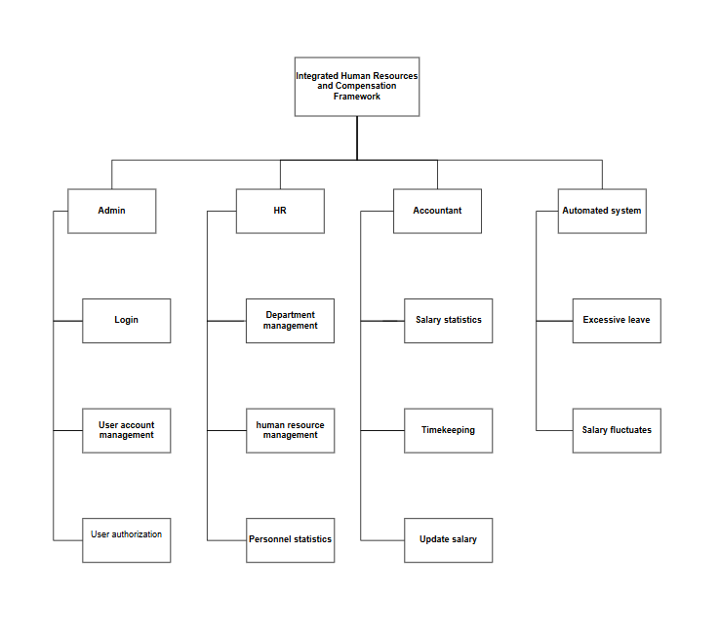

5.2. List of Use Case
Use case ID | Use case name | Functional Req.
UC.01 | System Login | FR.SYS.01
UC.02 | User Account Management | FR.ADM.01
UC.03 | User Permission/Role Management | FR.ADM.02
UC.04 | Department Management | FR.HR.01
UC.05 | Human Resource Management | FR.HR.02
UC.06 | Personnel Statistics | FR.HR.03
UC.07 | Payroll Statistics | FR.KT.01
UC.08 | Timekeeping / Attendance | FR.KT.02
UC.09 | Payroll Update | FR.KT.03
UC.10 | Over-leave Tracking | FR.AUTO.01
UC.11 | Salary Fluctuations | FR.AUTO.02

5.3. Use Case Diagram Overview
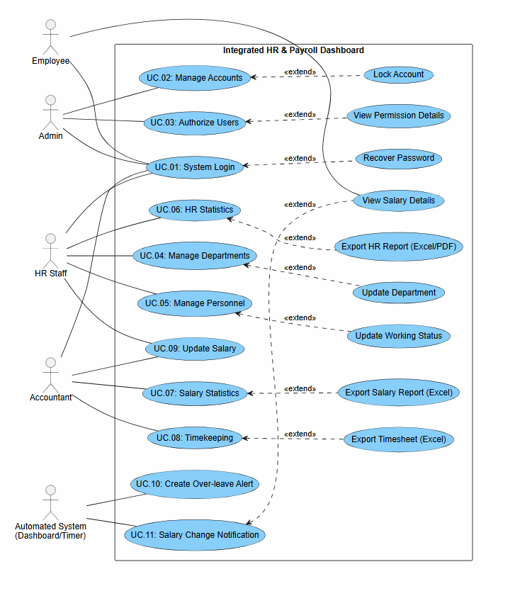

5.4. Use Case Specification

5.4.1. UC.01: System Login
Use Case ID | UC.01
Use Case Name | System Login
Created by | Tran Tin |  | Last updated by |  | Tran Tin
Date Created | Jan 21, 2026 |  | Date last updated |  | Jan 22, 2026
Actors | Admin, HR Staff, Accountant
Brief Description | Allows users to authenticate their identity to access the system based on their assigned permissions.
Goal | To ensure that only authorized users can access the system's functionalities.
Trigger | The user opens the application or accesses the system's URL/web address.
Pre-conditions | 1. The user must have an account (Username and Password) provided by the Admin.  2. The user's device must be connected to the internet.
Post-conditions | The user successfully logs in and is redirected to the Dashboard corresponding to their role.
Main Flow | Step | Actor Action |  | System Response
 | 1 | The user accesses the system URL. |  | Displays the login form (including Username, Password fields, and Login button).
 | 2 | The user enters their Username and Password. |  | The system records the input information.
 | 3 | The user clicks the "Login" button. |  | The system verifies the credentials in the database.
 | 4 |  |  | If the information is correct: The system redirects the user to the Home page (Dashboard).
 | Alternative Flow: Forgot Password
Alternative Flow | Step | Actor Action |  | System Response
 | 1 | On the login screen, the user clicks the "Forgot Password" link. |  | Displays a screen requesting a recovery email.
 | 2 | The user enters the registered email and clicks "Send". |  | The system verifies the email. If it exists, sends a password reset link to that email.
 | 3 | The user opens the email and clicks the link. |  | Displays the "Reset Password" screen.
 | 4 | The user enters and confirms the new password. |  | The system updates the new password and prompts the user to log in again.
 | Exception Flow: Incorrect Information
Exception Flow | Step | Actor Action |  | System Response
 | 1 | The user enters an incorrect Username or Password and clicks "Login". |  | The system displays a red error message: "Incorrect username or password."
 | 2 | The user leaves fields blank and clicks "Login". |  | The system displays a warning: "Please fill in all required information."
Priority | Cao
Business Rule | 1. Passwords must be at least 8 characters long, including uppercase letters, lowercase letters, and numbers.  2. Accounts will be temporarily locked for 30 minutes after 5 consecutive failed login attempts to prevent brute-force attacks.

5.4.2. UC.02: User Account Management
Use Case ID | UC.02
Use Case Name | User Account Management
Created by | Tran Tin |  | Last updated by |  | Tran Tin
Date Created | Jan 21, 2026 |  | Date last updated |  | Jan 21, 2026
Actors | Admin
Brief Description | The Admin performs operations to add new accounts, update information, assign permissions, or deactivate user accounts (HR, Accountant).
Goal | To manage the lifecycle and access permissions of accounts within the system.
Trigger | The Admin selects the "Account Management" function from the navigation menu.
Pre-conditions | 1. Admin has logged in successfully.  2. Admin holds the highest administrative privileges.
Post-conditions | New account information or changes are updated in the database.
Main Flow | Step | Actor Action |  | System Response
 | 1 | Admin clicks the "Create New Account" button on the list interface. |  | The system displays the input form (Username, Password, Email, Role).
 | 2 | Admin enters all required information and selects a Role (HR or Accountant). |  | The system records the input data.
 | 3 | Admin clicks the "Save" button. |  | The system validates the data and checks if the username already exists.
 | 4 |  |  | If valid: The system saves the new account to the database and displays the message "Account created successfully."
 | 5 |  |  | Updates the account list to display the newly created account.
 | Alternative Flow: Lock Account
Alternative Flow | Step | Actor Action |  | System Response
 | 1 | From the account list, Admin finds the target account and clicks the "Lock" button (or lock icon). |  | The system displays a confirmation dialog: "Are you sure you want to lock this account?".
 | 2 | Admin clicks "Confirm/Agree". |  | The system updates the account status to "Inactive" (Deactivated).
 | 3 |  |  | Displays the message "Account locked successfully."
 | Exception Flow: Invalid Data
Exception Flow | Step | Actor Action |  | System Response
 | 1 | Admin enters an existing Username and clicks "Save". |  | The system displays an error: "Username is already in use. Please choose another name."
 | 2 | Admin enters an incorrect Email format (e.g., missing @). |  | The system displays an error at the input field: "Invalid email format."
Priority | High
Business Rule | 1. Uniqueness: The Username must be unique and cannot be duplicated.  2.Self-Protection: The Admin cannot delete or downgrade the permissions of their own account.  3.Access Control: Locked accounts cannot log in until they are reactivated.

5.4.3. UC.03: User Authorization
Use Case ID | UC.03
Use Case Name | User Authorization
Created by | Tran Tin |  | Last updated by |  | Tran Tin
Date Created | Jan 21, 2026 |  | Date last updated |  | Jan 21, 2026
Actors | Admin
Brief Description | Allows the Administrator to set and change roles for employee accounts (e.g., assigning as HR or Accountant) to restrict access to corresponding features.
Goal | To ensure security and separation of duties within the system (RBAC - Role-Based Access Control).
Trigger | The Admin accesses the "Account Management" section and selects "Assign Permissions" (or "Role Assignment").
Pre-conditions | 1. Admin has successfully logged into the system.  2. The target account already exists in the system.
Post-conditions | User permissions are immediately updated in the database and applied in the next working session.
Main Flow | Step | Actor Action |  | System Response
 | 1 | Admin selects an account from the user list. |  | The system displays account information and existing roles.
 | 2 | Admin selects a new role from the list (HR, Accountant, Employee). |  | The system records the selection and waits for confirmation.
 | 3 | Admin clicks "Save Changes". |  | The system validates the conditions, updates the database, and displays a "Success" message.
 | Alternative Flow: Update Information
Alternative Flow | Step | Actor Action |  | System Response
 | 1 | Admin clicks the "Permission Details" icon next to a role. |  | The system displays a list of features (corresponding to Functional Requirements - FRs) that the role is authorized to use.
 | 2 | Admin clicks "Close". |  | The system returns to the original account management screen.
 | Exception Flow: Invalid Data
Exception Flow | Step | Actor Action |  | System Response
 | 1 | Admin attempts to remove the Admin role from the last remaining Administrator account. |  | The system checks the total number of Admin accounts in the database.
 | 2 |  |  | The system blocks the action and displays an error message: "Cannot revoke the system's last Administrator role."
Priority | High
Business Rule | 1. All changes to permissions must be recorded in the Audit Log along with the ID of the person who performed the action.  2. An account may be assigned one or more roles depending on job requirements.  3. New permissions will take effect immediately in the user’s next session.

5.4.4. UC.04: Department Management
Use Case ID | UC.04
Use Case Name | Department Management
Created by | Tran Tin |  | Last updated by |  | Tran Tin
Date Created | Jan 21, 2026 |  | Date last updated |  | Jan 21, 2026
Actors | HR Staff
Brief Description | Allows HR staff to perform operations such as adding new departments, editing department information, or updating the company's organizational structure.
Goal | To maintain an accurate department directory to support personnel allocation and statistical reporting.
Trigger | HR selects the "Department Management" function from the main menu bar.
Pre-conditions | 1. HR has successfully logged into the Dashboard system.  2. HR holds the permissions to edit organizational structure data.
Post-conditions | Department information is successfully stored or updated in the system database.
Main Flow | Step | Actor Action |  | System Response
 | 1 | HR clicks the "Add New Department" button on the management interface. |  | The system displays the input form (Department Name, Department Code, Description, Head of Department...).
 | 2 | HR enters all required information and clicks the "Save" button. |  | The system validates the data (checking for duplicate names, code format, etc.).
 | 3 |  |  | If valid: The system saves the information to the database and displays the message "Department added successfully."
 | 4 | HR clicks "Close" to return to the list. |  | The system reloads the list page and displays the newly created department.
 | Alternative Flow: Update Information
Alternative Flow | Step | Actor Action |  | System Response
 | 1 | In the department list, HR searches for and clicks the "Edit" button (pencil icon). |  | The system displays a form populated with the department's current information.
 | 2 | HR modifies the necessary information (e.g., changing the Head of Department) and clicks "Update". |  | The system validates the modified data.
 | 3 |  |  | The system saves the changes and displays the message "Update successful".
 | Exception Flow: Invalid Data
Exception Flow | Step | Actor Action |  | System Response
 | 1 | HR enters a department name that already exists in the system and clicks "Save". |  | The system checks the database and detects a duplicate entry.
 | 2 |  |  | The system displays an error: "Department name already exists. Please check again."
 | 3 | HR leaves required fields blank (e.g., Department Name) and clicks "Save". |  | The system validates the input and displays a warning: "Please enter all required information."
Priority | High
Business Rule | 1. The Department Code must be unique and cannot be changed after it has been created.  2. Deleting a department is not allowed if there are still employees assigned to it.  3. All changes to department information must be accurately synchronized with the Payroll system.

5.4.5. UC.05: HR Management
Use Case ID | UC.05
Use Case Name | HR Management
Created by | Tran Tin |  | Last updated by |  | Tran Tin
Date Created | Jan 21, 2026 |  | Date last updated |  | Jan 21, 2026
Actors | HR Staff
Brief Description | Allows HR staff to manage detailed employee information, including: creating new profiles, updating personal details, educational background, and employment status.
Goal | To store and centrally manage all personnel information of Company X, serving as the master data source for synchronization with the payroll system.
Trigger | HR selects the "Employee List" function on the Dashboard.
Pre-conditions | 1. HR has successfully logged in.  2. Department and Position categories have been previously established.
Post-conditions | Personnel information is updated in the HUMAN_2025 database and is ready for synchronization with the PAYROLL DB.
Main Flow | Step | Actor Action |  | System Response
 | 1 | HR clicks the "Add New Employee" button. |  | The system displays the employee profile form (Full Name, DOB, ID Card No., Email, Department, Base Salary...).
 | 2 | HR enters all information and clicks "Save Profile". |  | The system validates the data (email format, unique ID Card No., etc.).
 | 3 |  |  | The system saves the data to SQL Server and displays the message "Employee added successfully."
 | 4 |  |  | The system automatically triggers the synchronization process of basic info to the Payroll system's MySQL database.
 | Alternative Flow: Update Information
Alternative Flow | Step | Actor Action |  | System Response
 | 1 | HR searches for an employee and selects "Update Status". |  | The system displays status options: Active, Maternity Leave, Resigned.
 | 2 | HR selects the new status and clicks "Confirm". |  | The system updates the status and change date in the profile.
 | Exception Flow: Invalid Data
Exception Flow | Step | Actor Action |  | System Response
 | 1 | HR enters an ID Card No. that already exists and clicks "Save". |  | The system checks for duplicates in the database.
 | 2 |  |  | The system blocks the action and displays a warning: "Error: This ID Card No. is already used for another employee."
Priority | High
Business Rule | 1. Uniqueness: Each employee must have a unique and non-duplicated Employee ID.  2. Account Access: When an employee's status changes to "Resigned", their system login account must be automatically locked.  3. Audit Trail: Any changes to the base salary in the personnel file must be logged for reconciliation with the Payroll Accountant.

5.4.6. UC.06: HR Statistics
Use Case ID | UC.06
Use Case Name | HR Statistics
Created by | Duy Manh |  | Last updated by |  | Duy Manh
Date Created | Jan 21, 2026 |  | Date last updated |  | Jan 21, 2026
Actors | HR Staff (Human Resources)
Brief Description | The system provides reports and charts regarding personnel status (headcount, turnover/fluctuations, gender ratio, and distribution by department).
Goal | To help the HR department and Board of Directors quickly grasp the company's resource situation.
Trigger | HR selects the "Personnel Statistics" or "Reports" menu on the navigation bar.
Pre-conditions | 1. HR has successfully logged in.2. Personnel data is already available in the system.
Post-conditions | Charts and statistical data are displayed visually or exported to report files.
Main Flow | Step | Actor Action |  | System Response
 | 1 | HR accesses the "Personnel Statistics" screen. |  | The system displays the default overview Dashboard (Total employees, pie chart of distribution by department).
 | 2 | HR selects filter criteria (e.g., Department: "Sales" and Timeframe: "Year 2025"). |  | The system records the filter selection.
 | 3 | HR clicks the "View Report" or "Filter" button. |  | The system queries the data and updates the charts/metrics based on the selected criteria.
 | 4 | HR views the detailed metrics on the screen. |  | The system maintains the displayed results.
 | Alternative Flow: Export Report to File
Alternative Flow | Step | Actor Action |  | System Response
 | 1 | After viewing the data, HR clicks the "Export" button and selects the file format (Excel or PDF). |  | The system processes the data and generates a downloadable file.
 | 2 | HR selects the destination folder on their computer and confirms. |  | The system displays the message "File exported successfully" and completes the download process.
 | Exception Flow: No Data Found
Exception Flow | Step | Actor Action |  | System Response
 | 1 | HR selects a future timeframe or a new department with no personnel and clicks "Filter". |  | The system displays the message: "No data found matching the search criteria."
 | 2 |  |  | The Dashboard displays an empty state (0 employees).
Priority | Medium
Business Rule | 1. Statistical data must accurately reflect the actual situation at the time of retrieval (real-time).  2. HR can only view general statistics and cannot access detailed salary information of individual employees on this screen (this permission belongs to the Accounting department).

5.4.7. UC.07: Salary Statistics
Use Case ID | UC.07
Use Case Name | Salary Statistics
Created by | Duy Manh |  | Last updated by |  | Duy Manh
Date Created | Jan 21, 2026 |  | Date last updated |  | Jan 21, 2026
Actors | Accountant
Brief Description | The system aggregates and displays reports on the salary fund, payroll costs, taxes, and insurance contributions for a specific period.
Goal | To provide a comprehensive overview of the financial situation related to personnel, supporting financial reporting and cash flow planning.
Trigger | The Accountant selects the "Payroll Management" module > "Statistics" on the menu bar.
Pre-conditions | 1. The Accountant has successfully logged in and holds access rights to payroll data.  2. Payroll data for the reporting period has been calculated and finalized (timesheet closed).
Post-conditions | The report is accurately displayed or the report file is downloaded to the workstation.
Main Flow | Step | Actor Action |  | System Response
 | 1 | Accountant selects filter criteria: Time (Month/Year) and Department (or "Entire Company"). |  | The system displays the available filter options.
 | 2 | Accountant clicks the "View Statistics" button. |  | The system retrieves data from the payroll tables stored in the database.
 | 3 |  |  | The system displays a Dashboard including: Total Net Salary, Total Social Insurance, Total PIT (Personal Income Tax), and a fluctuation chart compared to the previous month.
 | 4 | Accountant views the detailed figures. |  | The system maintains the data display.
 | Alternative Flow: Export Excel Report
Alternative Flow | Step | Actor Action |  | System Response
 | 1 | On the statistics screen, the Accountant clicks the "Export Excel" button. |  | The system processes and generates an .xlsx file containing the detailed data of the current statistics view.
 | 2 | Accountant confirms the download. |  | The system displays the message "Download complete" and the file is saved to the computer.
 | Exception Flow: No Payroll Data Available
Exception Flow | Step | Actor Action |  | System Response
 | 1 | Accountant selects a future month or a month where payroll has not been finalized and clicks "View Statistics". |  | The system checks and identifies that the data is empty.
 | 2 |  |  | The system displays a notification: "No payroll data available for this period. Please calculate payroll before viewing statistics."
Priority | High
Business Rule | 1. Salary data is confidential; only the Chief Accountant or authorized personnel can access company-wide information.  2. Financial figures must be rounded according to the specified currency unit (VND)

5.4.8. UC.08: Attendance Tracking
Use Case ID | UC.08
Use Case Name | Attendance Tracking
Created by | Duy Manh |  | Last updated by |  | Duy Manh
Date Created | Jan 21, 2026 |  | Date last updated |  | Jan 21, 2026
Actors | Accountant
Brief Description | Allows the Accountant to monitor, verify, and confirm attendance data, including workdays, overtime hours, and leave days from the PAYROLL database.
Goal | To ensure that attendance data is accurate and transparent, serving as the basis for month-end salary calculations.
Trigger | The Accountant selects the "Attendance Management" function from the Dashboard navigation menu.
Pre-conditions | 1. The Accountant has successfully logged into the system.  2. Raw data from timekeeping machines or attendance sheets has been imported into the PAYROLL DB (MySQL).
Post-conditions | The attendance sheet is verified and the status is finalized to proceed to the payroll calculation step.
Main Flow | Step | Actor Action |  | System Response
 | 1 | Accountant selects the attendance period (Month/Year) and the department to be checked. |  | The system queries data from the attendance table in the PAYROLL DB.
 | 2 | Accountant reviews actual workdays, OT hours, and paid/unpaid leave days for each employee. |  | The system displays a detailed table with notes on anomalies (late arrivals, early departures).
 | 3 | Accountant corrects errors (if any) and clicks "Confirm Attendance Sheet". |  | The system saves the status as "Confirmed" and records the action in the system log.
 | Alternative Flow: Export Attendance Data
Alternative Flow | Step | Actor Action |  | System Response
 | 1 | On the attendance screen, the Accountant clicks the "Export Excel" button. |  | The system aggregates the data and generates an .xlsx file containing the workday details for all employees.
 | 2 | Accountant selects the storage location and completes the download. |  | The system displays the message "Download complete".
 | Exception Flow: Connection Error
Exception Flow | Step | Actor Action |  | System Response
 | 1 | Accountant clicks "View Data" but encounters a connection error to the PAYROLL DB. |  | The system records a timeout error in the system log.
 | 2 |  |  | The system displays a warning: "Database server connection error. Please try again later."
Priority | High
Business Rule | 1. Rounding Rule: Workday data must be rounded according to Company X's regulations (e.g., a minimum of 0.5 workday).  2. Editing Privileges: Only Accountants or Admins have the authority to adjust actual workday figures.  3. Data Locking: Once the attendance sheet has transitioned to "Payroll Finalized" status, no further modifications to attendance data are permitted.

5.4.9. UC.09: Salary Update
Use Case ID | UC.09
Use Case Name | Salary Update
Created by | Viet Loc |  | Last updated by |  | Viet Loc
Date Created | Jan 21, 2026 |  | Date last updated |  | Jan 21, 2026
Actors | Accountant, HR Manager
Brief Description | Allows users (based on permissions) to adjust and update base salary, allowances, bonuses, or deductions for employees.
Goal | To ensure the accuracy of the payroll before finalization and distribution to employees.
Trigger | User selects the "Update Salary" function from the Dashboard menu or double-clicks on a specific salary record.
Pre-conditions | 1. The user has successfully logged in and holds "Update Salary" permissions.  2. The payroll for the current period is not yet in "Approved" (Finalized) status.
Post-conditions | The new salary data is saved to the PAYROLL database and the display on the screen is updated.
Main Flow | Step | Actor Action |  | System Response
 | 1 | User selects the "Update Salary" item on the menu. |  | The system displays the employee list with current salary information (Base salary, allowances, deductions, net pay...).
 | 2 | User selects an employee and clicks "Update" (or double-clicks the record). |  | The system displays a detailed input form for salary components.
 | 3 | User enters/adjusts figures (bonuses, penalties, allowances...). |  | The system automatically recalculates the "Net Pay" column based on the newly entered data.
 | 4 | User clicks the "Confirm" (Save) button. |  | The system validates the data integrity.
 | 5 |  |  | If valid: The system saves to the PAYROLL database and displays the message "Salary data updated successfully."
 | Alternative Flow: Cancel Action
Alternative Flow | Step | Actor Action |  | System Response
 | 1 | On the salary update form, the user clicks the "Cancel" button. |  | The system closes the form without saving any changes and returns to the original salary list.
 | Exception Flow: Connection Error
Exception Flow | Step | Actor Action |  | System Response
 | 1 | User clicks "Confirm" (Save) but the system loses network connection or the PAYROLL server is under maintenance. |  | The system records the connection error.
 | 2 |  |  | The system displays a warning: "Error: Lost connection to the data server. Please check your network or contact the Admin."
Priority | Medium
Business Rule | 1. Access Control: Only Accountants or HR Managers (with assigned permissions) are allowed to update salaries.  2 .Read-Only Restriction: Regular employees are only permitted to view (Read-only) and strictly prohibited from editing data.  3. Audit Trail: Every data update must be recorded in the Audit Log for reconciliation and auditing purposes.

5.4.10. UC.10: Create Excess Leave Alert
Use Case ID | UC.10
Use Case Name | Create Excess Leave Alert
Created by | Viet Loc |  | Last updated by |  | Viet Loc
Date Created | Jan 21, 2026 |  | Date last updated |  | Jan 21, 2026
Actors | Dashboard System
Brief Description | The Dashboard system automatically scans attendance data from the PAYROLL database and generates alerts if an employee's leave days exceed the regulated limit.
Goal | To help management proactively detect cases of excessive leave for timely handling without the need for manual review.
Trigger | The system runs periodically (e.g., at the end of each week or before the payroll finalization period).
Pre-conditions | 1. The Dashboard has successfully connected to the PAYROLL database (MySQL).  2. The LeaveDays data in the attendance table has been updated.
Post-conditions | Alerts are generated and stored in the Dashboard system to be displayed to the Admin/HR Manager.
Main Flow | Step | Actor Action |  | System Response
 | 1 | At the scheduled time, the Dashboard System triggers the automated checking process. |  | The system connects to the PAYROLL database via API or Data Access Layer (DAL).
 | 2 |  |  | The system queries LeaveDays (number of days off) from the attendance table for all employees.
 | 3 | The system compares LeaveDays with the allowed leave limit (configured within the Dashboard). |  | The system identifies the list of employees whose LeaveDays exceed the permitted limit.
 | 4 |  |  | For each violation, the system creates an "Alert" record in the Dashboard database.
 | 5 |  |  | The system logs the data scanning process for audit purposes (Audit Logging).
 | Exception Flow: Data Connection Failure
Exception Flow | Step | Actor Action |  | System Response
 | 1 | The system attempts to connect to the PAYROLL DB (MySQL) but fails (due to timeout or network error). |  | The system records the connection error in the System Log.
 | 2 |  |  | The system cancels the current scan session and schedules a retry.
 | 3 |  |  | A technical error notification is sent to the System Admin.
Priority | Medium
Business Rule | 1. Schema Integrity: The Dashboard must not modify the table structure of the PAYROLL database to add alert columns.  2. Logic Separation: All logic for checking leave limits must be executed at the Dashboard application layer.

5.4.11. UC.11: Salary Fluctuation Notification
Use Case ID | UC.11
Use Case Name | Salary Fluctuation Notification
Created by | Viet Loc |  | Last updated by |  | Viet Loc
Date Created | Jan 21, 2026 |  | Date last updated |  | Jan 21, 2026
Actors | Automated System
Brief Description | The system automatically aggregates non-fixed salary components (variable pay: bonuses, OT, deductions) and sends detailed notifications/payslips to each employee's account.
Goal | To help employees clearly understand their variable income components for the month as soon as the payroll is released.
Trigger | Immediately after the Chief Accountant clicks the "Finalize Payroll" and "Release" buttons on the system.
Pre-conditions | 1. The monthly payroll has been calculated and approved.  2. Employees have a valid account on the Dashboard.
Post-conditions | Employees receive a notification and can view the details of their variable pay on the Dashboard.
Main Flow | Step | Actor Action |  | System Response
 | 1 | Accountant performs the "Release Payroll" action (Trigger). |  | The system activates the payslip distribution process.
 | 2 | The system automatically extracts detailed data for each employee from the DB (Base salary, Bonuses, Deductions, Taxes). |  | The system generates an "E-Payslip" for the current month.
 | 3 |  |  | The system highlights Variable Pay components (Comparing increase/decrease vs. previous month or listing detailed allowances).
 | 4 | The system sends a notification to employees (via Email or App Notification): "Your payslip for month [X] is ready. Please check your variable components." |  | The system updates the payroll status to "Sent".
 | Alternative Flow: Employee views directly on Dashboard
Alternative Flow | Step | Actor Action |  | System Response
 | 1 | Employee logs in and clicks on the received notification. |  | The system displays the "Variable Pay Details" screen.
 | 2 |  |  | The system displays an analytical table:- Fixed: Base Salary.- Variable (+): Commissions, Overtime.- Variable (-): Unpaid leave, Social Insurance.
 | 3 | Employee clicks the "Confirm Viewed" button. |  | The system records that the employee has checked their salary.
 | Exception Flow: Notification Delivery Failure
Exception Flow | Step | Actor Action |  | System Response
 | 1 | The system sends a notification email, but the employee's email address is invalid or non-existent. |  | The system records a "Delivery Failed" status.
 | 2 |  |  | The system generates an alert for HR to update the contact information for that specific employee.
Priority | High
Business Rule | 1. Confidentiality: Salary information is strictly confidential; employees are only permitted to view their own salary details.  2. Detail Level: Variable components must be listed in detail (e.g., 10h Overtime, KPI Bonus, Penalty for late arrival, etc.).

5.5. Activity Diagram

5.5.1. UC.01: System Login
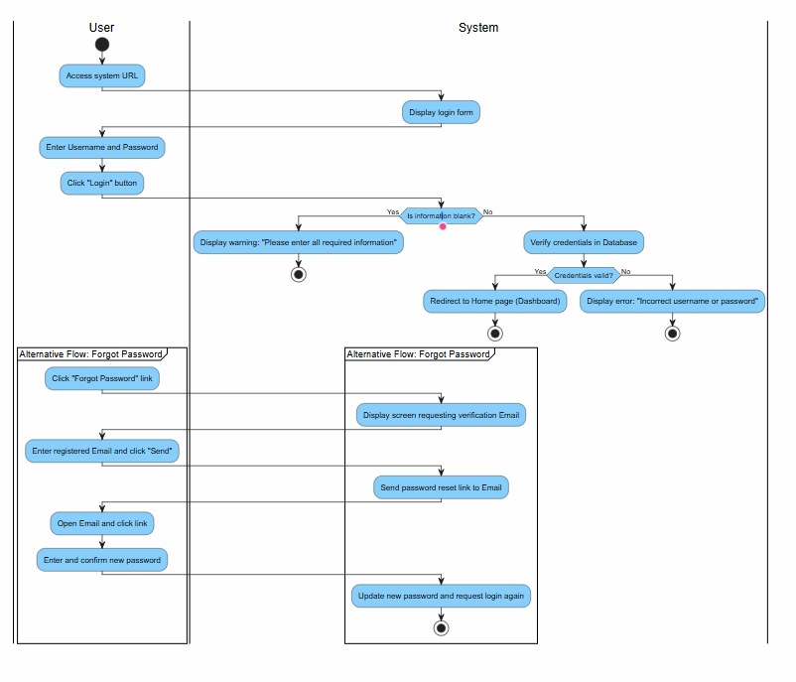
Figure 1UC.01: System Login

5.5.2. UC.02: User Account Management
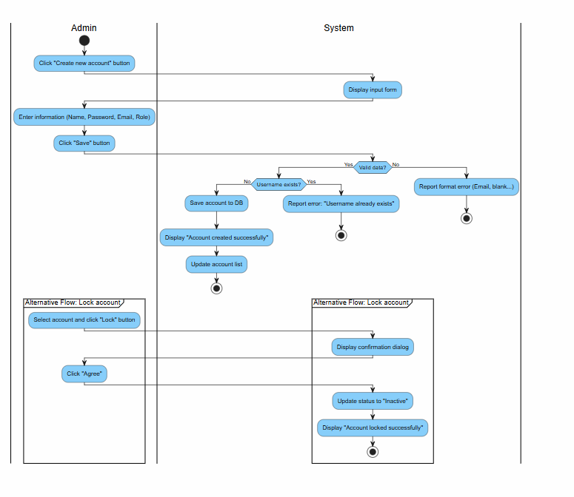
Figure 2UC.02: User Account Management

5.5.3. UC.03: User Authorization
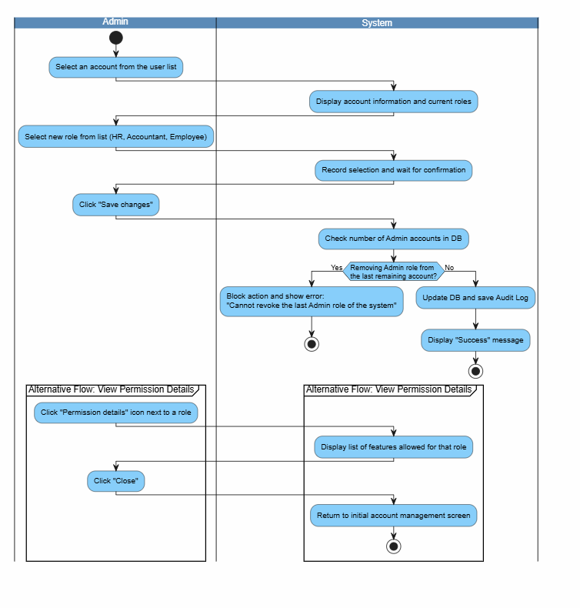
Figure 3UC.03: User Authorization

5.5.4. UC.04: Department Management
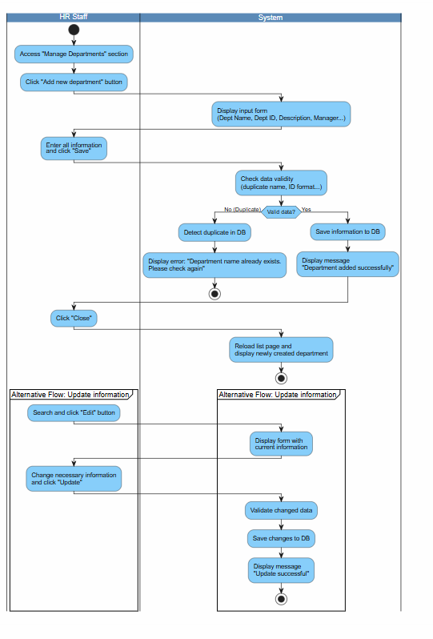
Figure 4UC.04: Department Management

5.5.5. UC.05: HR Management
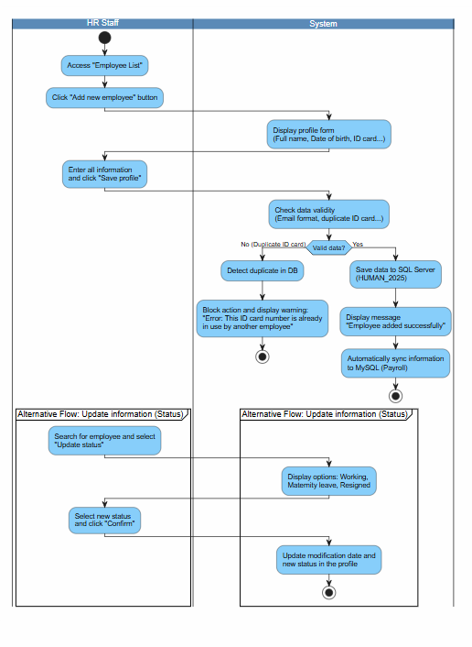
Figure 5HR Management

5.5.6. UC.06: HR Statistics
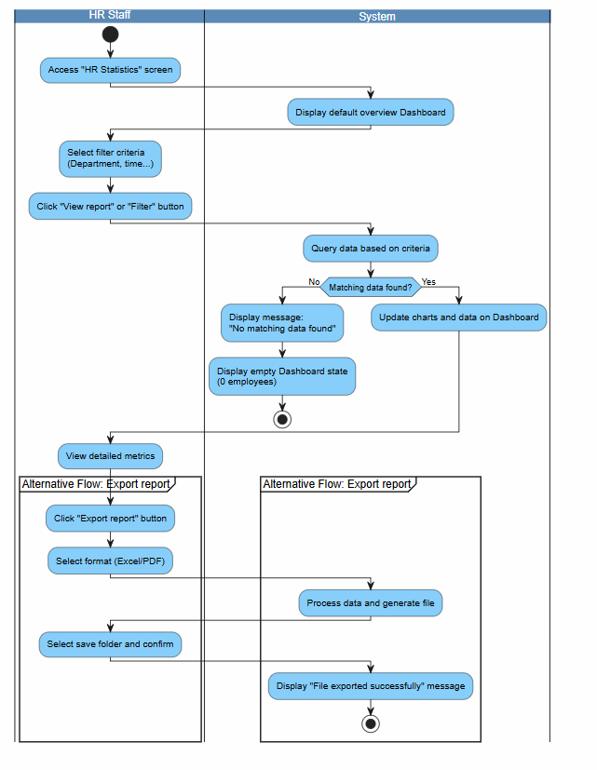
Figure 6UC.06: HR Statistics

5.5.7. UC.07: Payroll Statistics
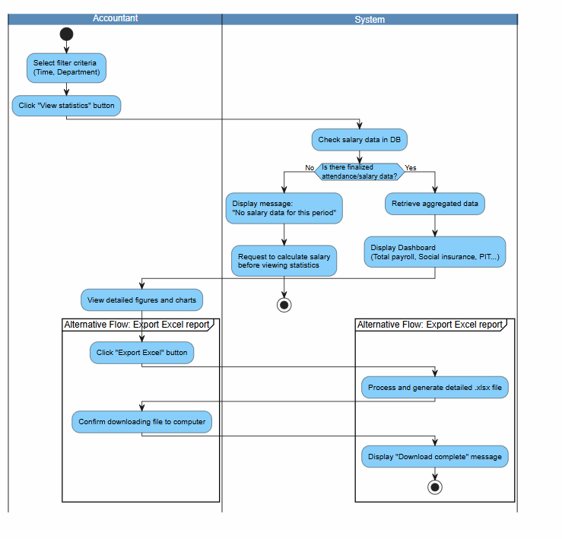
Figure 7UC.07: Payroll Statistics

5.5.8. UC.08: Timekeeping
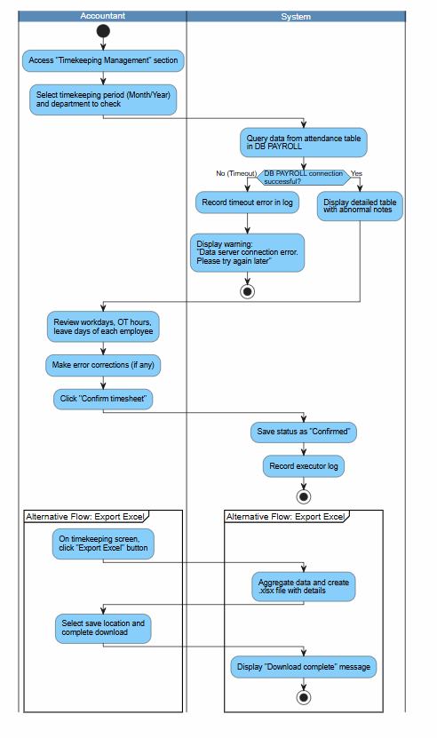
Figure 8UC.08: Timekeeping

5.5.9. UC.09: Update Salary
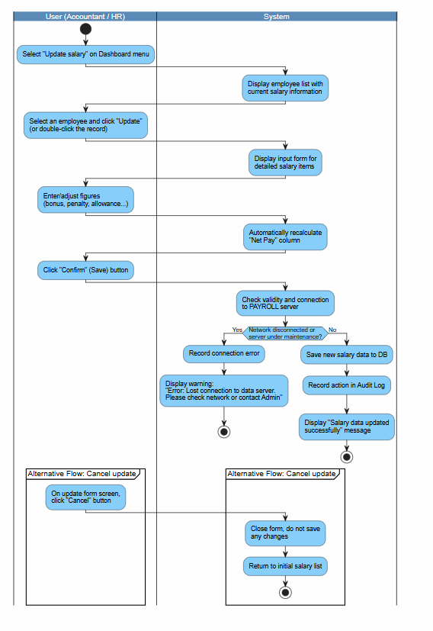
Figure 9UC.09: Update Salary

5.5.10. UC.10: Excess Leave
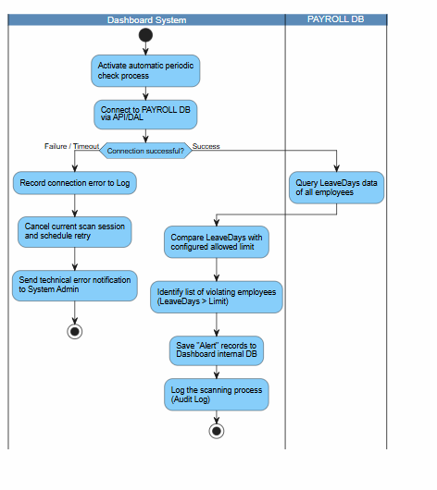
Figure 10UC.10: Excess Leave

5.5.11. UC.11: Salary Change Notification
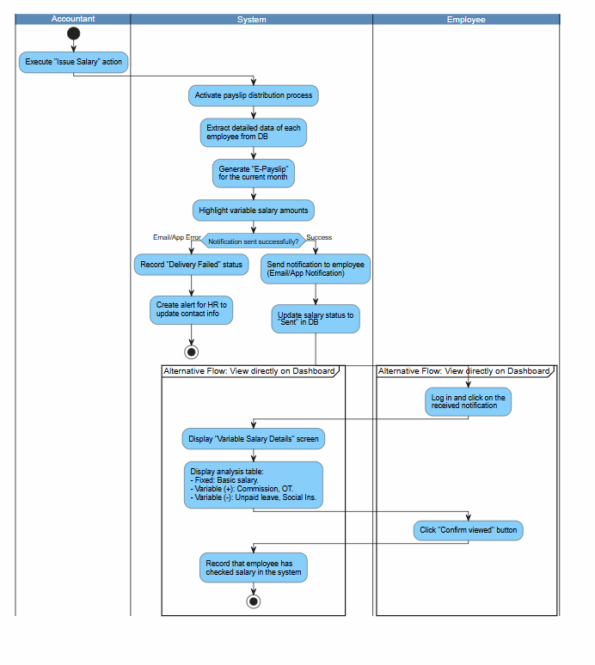
Figure 11UC.11: Salary Change Notification

5.6. Sequence Diagram

5.6.1. UC.01: System Login
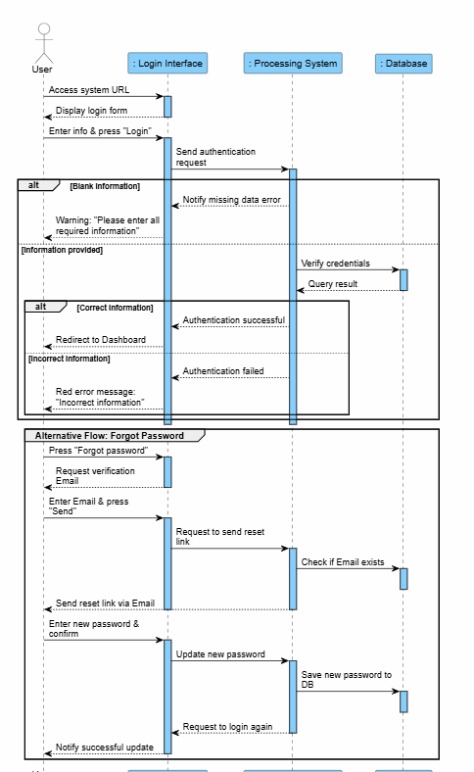
Figure 12UC.01: System Login

5.6.2. UC.02: User Account Management
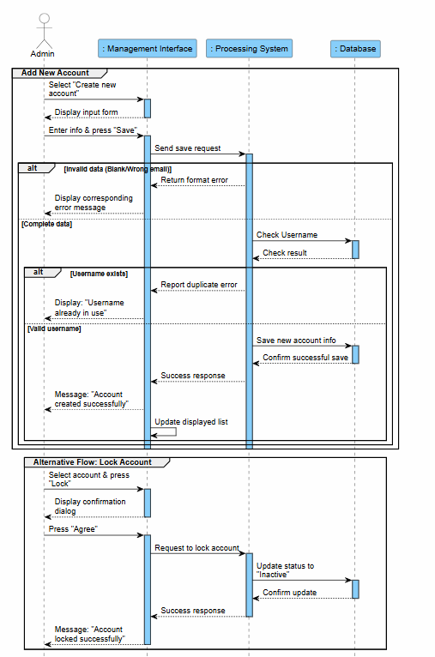
Figure 13UC.02: User Account Management

5.6.3. UC.03: User Authorization
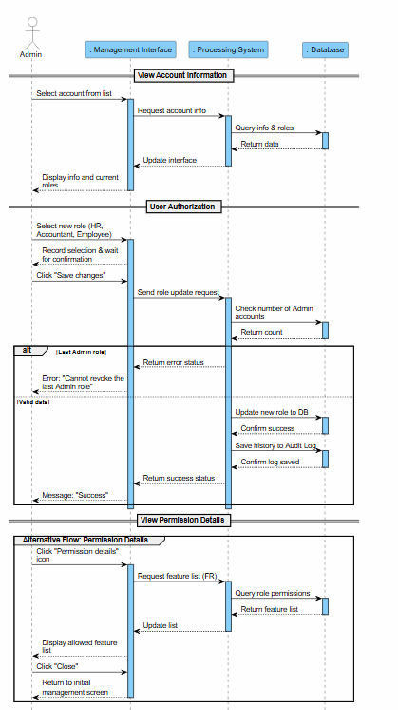
Figure 14UC.03: User Authorization

5.6.4. UC.04: Department Management
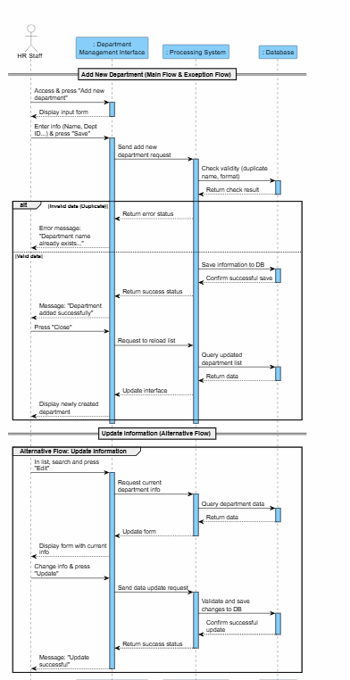
Figure 15UC.04: Department Management

5.6.5. UC.05: HR Management
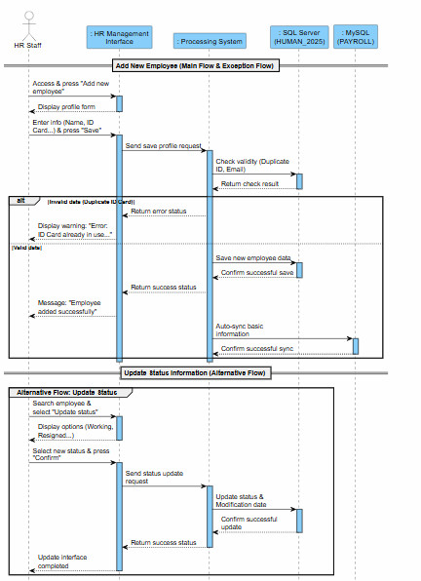
Figure 16UC.05: HR Management

5.6.6. UC.06: HR Statistics
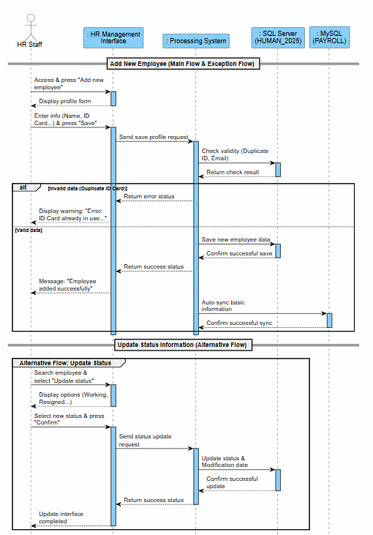
Figure 17UC.06: HR Statistics

5.6.7. UC.07: Salary Statistics
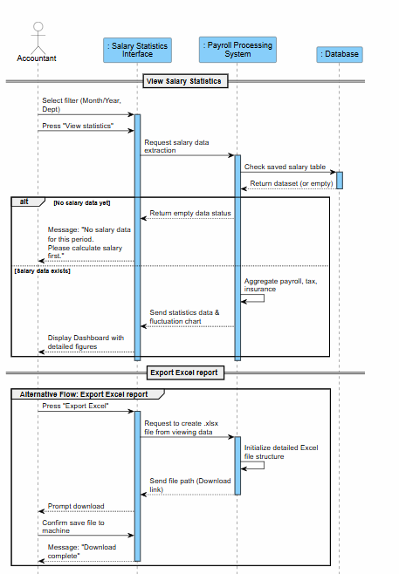
Figure 18UC.07: Salary Statistics

5.6.8. UC.08: Timekeeping
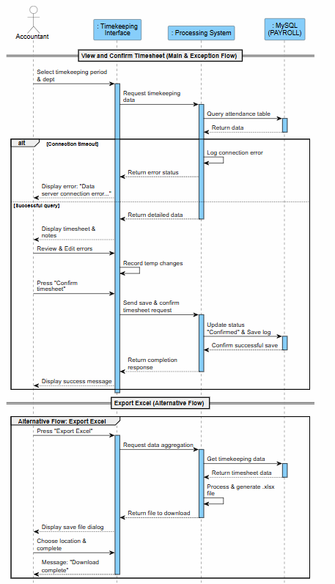
Figure 19UC.08: Timekeeping

5.6.9. UC.09: Update Salary
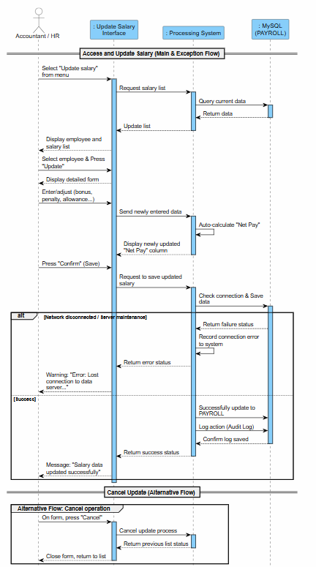
Figure 20UC.09: Update Salary

5.6.10. UC.10: Excess Leave
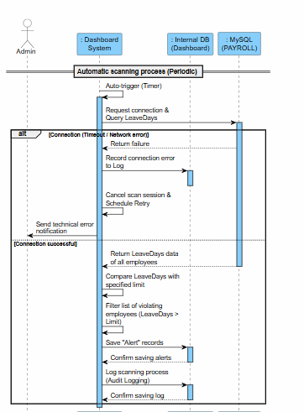
Figure 21UC.10: Excess Leave

5.6.11. UC.11: Salary Change Notification
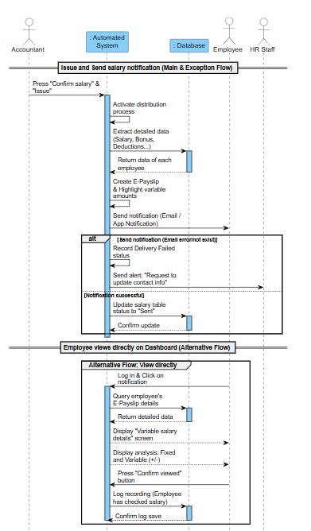
Figure 22UC.11: Salary Change Notification

5.7. Class Diagram
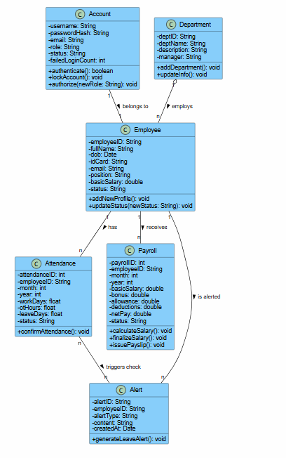

6. Other Requirements

6.1 Business Rules
ID | Business Rules
BR-01 | Each employee has a maximum of 12 days of annual leave per year.
BR-02 | Only the HR Manager is allowed to update salaries.
BR-03 | The account will be locked after 3 failed login attempts.
BR-04 | Passwords must be at least 8 characters long, including uppercase letters, lowercase letters, and numbers.
BR-05 | The Username and Employee ID must be unique and strictly not duplicated in the system.
BR-06 | Administrators (Admin) cannot delete or demote their own accounts to prevent the loss of system control.
BR-07 | New employees added to the system must be at least 18 years old as of their joining date.
BR-08 | Mandatory fields when creating a new personnel profile include: Full Name, Date of Birth, ID Card Number (CCCD), Department, and Position.
BR-09 | Salary information is strictly confidential: Employees can only view their own salaries. Only the Chief Accountant or authorized personnel can view the entire company payroll. +1
BR-10 | Salary history data is "Read-only". It is not allowed to be edited directly on the history screen and must be stored for a minimum of the last 5 years.
BR-11 | All logic for checking leave limits or creating alerts must be implemented at the Dashboard application layer; modifying the table structure in the original PAYROLL database is strictly prohibited.
BR-12 | Variable salary components must be detailed transparently on the electronic payslip (e.g., 10 hours overtime, KPI bonus, late penalty...).
BR-13 | Financial figures in reports must be rounded according to the specified currency (VND).

6.2. System Constraints
- Architecture & Deployment Constraints
- The system is a web-based application that acts as an intermediate middleware layer to handle data flow.
- The system must support flexible deployment on both Windows Server (using IIS) and Linux Server (using Tomcat or equivalent).
- Database Constraints
- Preservation of original data: It is strictly prohibited to interfere with, modify, or alter the database schema of the two existing databases: SQL Server (HUMAN_2025) and MySQL (PAYROLL). All data reading and writing operations must strictly comply with authorized APIs.
- Logic & Technology Constraints
- Artificial Intelligence (AI) Integration: For automated processing tasks, attendance data analysis, or violation alert prediction, the system is required to integrate AI models for processing. The use of rigid conditional programming structures (such as if-else) for these automated decision-making flows is strictly prohibited.
- Security Constraints
- All data communication between Client and Server, as well as between Middleware and Database Servers, must be encrypted using SSL/TLS protocols.
- User authentication must use JSON Web Token (JWT).
- User passwords must not be stored in plain text and must undergo one-way hashing.
- Performance Constraints
- Response time for data queries, chart rendering, and standard data synchronization operations must not exceed 2 seconds to ensure a good user experience.
- Client Environment Constraints
- The user interface must display properly and be fully compatible with modern popular web browsers such as Google Chrome and Microsoft Edge.

7. Appendix

7.1. Glossary
Term | Explanation
Dashboard | Overview page displaying personnel and salary information.
Payroll | System for salaries, bonuses, and allowances.
Leave Request | Employee's leave request.
Alert | Internal alerts within the system.

7.2. Appendix B – Requirement Traceability Matrix
Business Requirement Description | FR ID | Functional Requirement Description | API Endpoint (From Design Doc) | Test Case ID | Status
Each employee is entitled to a maximum of 12 days of annual leave. | FR.AUTO.01 | System automatically scans attendance data and generates alerts for excessive leave. | /api/dashboard/reconciliation | TC-INT-01 | Passed
Only the HR Manager is authorized to update salaries. | FR.ADM.01 | Allows Admin to manage user accounts, assign roles (HR, Accountant). | /api/auth/login (Role check) | TC-API-AUTH-01 | Passed
Account will be locked after 3 failed login attempts. | FR.SYS.01 | System allows users to authenticate identity using Username and Password. | /api/auth/login | TC-UNIT-AUTH-02 | Passed
Password must be at least 8 characters long, including uppercase, lowercase, and numbers. | FR.SYS.01 | System allows users to authenticate identity using Username and Password. | /api/auth/register | TC-UNIT-AUTH-01 | Passed
Username and Employee ID must be unique and cannot be duplicated. | FR.ADM.01, FR.HR.01 | Manage user accounts and personnel profiles (add new). | /api/auth/register | TC-API-REG-03 | Passed
Admins cannot delete or downgrade their own account permissions. | FR.ADM.01 | Allows Admin to manage user accounts, assign roles. | /api/auth/me (Validation) | TC-API-AUTH-04 | Passed
New employees added to the system must be at least 18 years old. | FR.HR.01 | Allows HR to manage personnel list (add new employee profiles). | /api/hr/schema (Validation) | TC-INT-HR-05 | Passed
Mandatory fields: Full Name, DOB, ID/CCCD, Department, and Position. | FR.HR.01 | Allows HR to manage personnel list (add new employee profiles). | /api/hr/schema | TC-INT-HR-06 | Passed
Salary confidentiality: Users only view their own. Chief Accountant views the total budget. | FR.KT.01 | System aggregates and displays salary statistical reports. | /api/dashboard/employee/{id} | TC-API-DASH-08 | Passed
Salary history data is "Read-only" and must be stored for at least 5 years. | FR.KT.02 | Allows Accountants to look up and view detailed salary adjustment history. | /api/payroll/schema (Audit track) | TC-API-PAY-10 | Passed
Leave limit checking logic is executed at the Dashboard, not the source DB. | FR.AUTO.01 | System scans attendance data and creates alerts on the Dashboard. | /api/dashboard/status | TC-INT-DASH-05 | Passed
Variable salary components must be transparently and detailed on payslips. | FR.AUTO.02 | System automatically aggregates variable components and sends E-Payslips. | /api/dashboard/overview | TC-API-DASH-06 | Passed
Financial figures in reports must be rounded according to the specified currency (VND). | FR.KT.01 | System aggregates and displays salary statistical and budget reports. | /api/dashboard/overview | TC-API-DASH-07 | Passed

